APPLICATION FORM
SUMMER SCHOOL 2019
North-Western State Medical University named after
I.I. Mechnikov

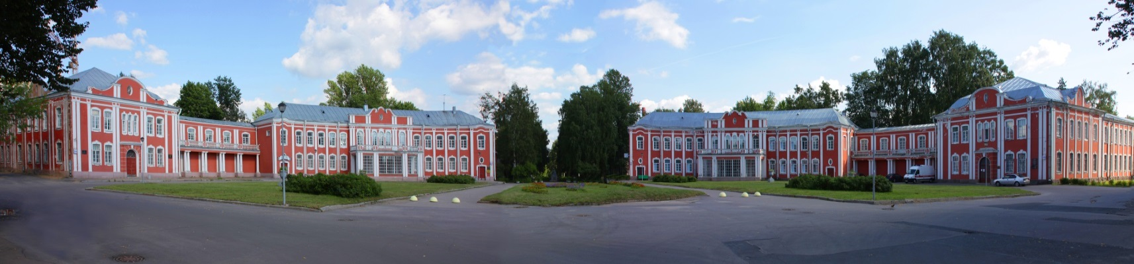

*Necessary to fill
*Обязательно для заполнения

*Name:
*Surname:
*Sex:
*Date of Birth:
*Home country:
*Choose a convenient time interval for you:
SUMMER, 2019
AUTUMN, 2019
*Select program language:
Russian
English
*Name of the University/organization:
*Education level
Student
Ph.D. student
Young Researcher
Other
*Contact phone:
*Contact e-mail:
Please send the filled form to the project manager Ms. Anastasia Barbolina anastasiya.barbolina@szgmu.ru

